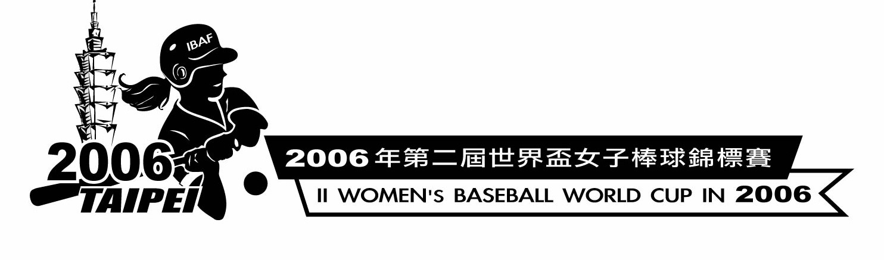

TEAMS' RANKING AFTER 6 DAYS OF COMPETITION

COUNTRY GP WO LO AVE GB

1.JAPAN 5 4 1 800 -
U.S.A. 5 4 1 800 -
3.AUSTRALIA 6 4 2 667 0.5
4.CANADA 5 3 2 600 1.0
5.CHINESE TAIPEI 5 2 3 400 2.0
6.CUBA 5 1 4 200 3.0
7.HONG KONG 5 0 5 0 4.0

RESULTS AFTER 6 DAYS OF COMPETITION

SCHEDULE DAY : 1
HONG KONG AUSTRALIA 2 - 22
CANADA U.S.A. 5 - 2
CHINESE TAIPEI JAPAN 0 - 9

SCHEDULE DAY : 2
CUBA CANADA 8 - 10
JAPAN HONG KONG 43 - 0
AUSTRALIA CHINESE TAIPEI 4 - 0

SCHEDULE DAY : 3
U.S.A. AUSTRALIA 7 - 2
HONG KONG CHINESE TAIPEI 2 - 21
CUBA JAPAN 0 - 15

SCHEDULE DAY : 4
U.S.A. HONG KONG 12 - 0
AUSTRALIA CUBA 5 - 4
JAPAN CANADA 3 - 6

SCHEDULE DAY : 5
JAPAN AUSTRALIA 11 - 6
CUBA U.S.A. 4 - 14
CANADA CHINESE TAIPEI 1 - 7

SCHEDULE DAY : 6
HONG KONG CUBA 4 - 14
CHINESE TAIPEI U.S.A. 1 - 3
AUSTRALIA CANADA 9 - 4

